Report Assignment 3: Unsupervised Learning on WINE Data
Author: Simone Magistrali
Email: smi25011@student.mdu.se
Course: Learning Systems DVA493
Professor: Ning Xiong
Semester: Fall 2025

1. Introduction and Objective
This report details the application of unsupervised learning to the WINE dataset, contrasting with the supervised regression focus of the previous assignment. The goal is to explore the data's inherent structure without using class labels.
Specific objectives:
- Perform PCA to reduce dataset dimensionality (13 features) while retaining maximum variance.
- Implement K-means clustering (K=3) using varying numbers of principal components as input.
The WINE.txt dataset contains 178 samples with 13 chemical characteristics, representing wines from three different Italian cultivars grown in the same region.

2. Data Preparation
Before applying PCA and K-means, the data required specific preprocessing steps, implemented in Python.

2.1. Feature Extraction and Cleaning
The class label column was removed for this unsupervised task. The remaining 13 columns form the feature matrix

2.2. Standardization
Due to PCA's sensitivity to feature scale, all 13 features were standardized using Z-score normalization. This process ensures equal contribution from all features, resulting in a mean of 0 and a standard deviation of 1.

3. Principal Component Analysis (PCA)
Principal Component Analysis (PCA) is a statistical procedure that uses an orthogonal transformation to convert a set of observations of possibly correlated variables into a set of values of linearly uncorrelated variables called principal components.
The fundamental principle of PCA is to reduce the dimensionality of a dataset while retaining as much statistical information (variance) as possible. This is achieved by identifying the directions (principal components) along which the data varies the most.
Mathematically, this involves calculating the covariance matrix of the standardized data and performing an eigendecomposition. The eigenvectors of the covariance matrix represent the directions of the principal components, while the corresponding eigenvalues represent the magnitude of the variance explained by that component.
The first principal component corresponds to the eigenvector with the largest eigenvalue, capturing the most significant variance. The second component is orthogonal to the first and captures the second highest variance, and so on. By projecting the original high-dimensional data onto a smaller subset of these eigenvectors (eg, the top 2, 5, or 8), we achieve dimension reduction, compressing the data and removing noise while revealing hidden patterns.

4. K-Means Clustering Algorithm
The objective of the K-means algorithm is to partition N observations into K distinct clusters, with each observation assigned to the cluster whose mean (centroid) is the nearest.
The algorithm operates through an iterative refinement process:
- Initialization: K centroids are initialized. In this implementation, they are chosen randomly from the existing data points.
- Assignment Step: Each data point is assigned to the closest cluster. The "closeness" is typically measured using the Euclidean distance between the data point and the cluster centroids.
- Update Step: The new centroids are calculated by taking the mean of all data points assigned to each specific cluster.
This iterative process, encompassing both the Assignment and Update steps, continues until a predefined convergence criterion is satisfied. Convergence is typically achieved when the cluster assignments stabilize, or, equivalently, when the movement of the centroids between consecutive iterations becomes negligible (or a predetermined maximum number of iterations is reached).
While efficient, the algorithm is sensitive to the initial placement of the centroids, which can lead to local optima rather than the global optimum.

5. Results

5.1. PCA Visualization
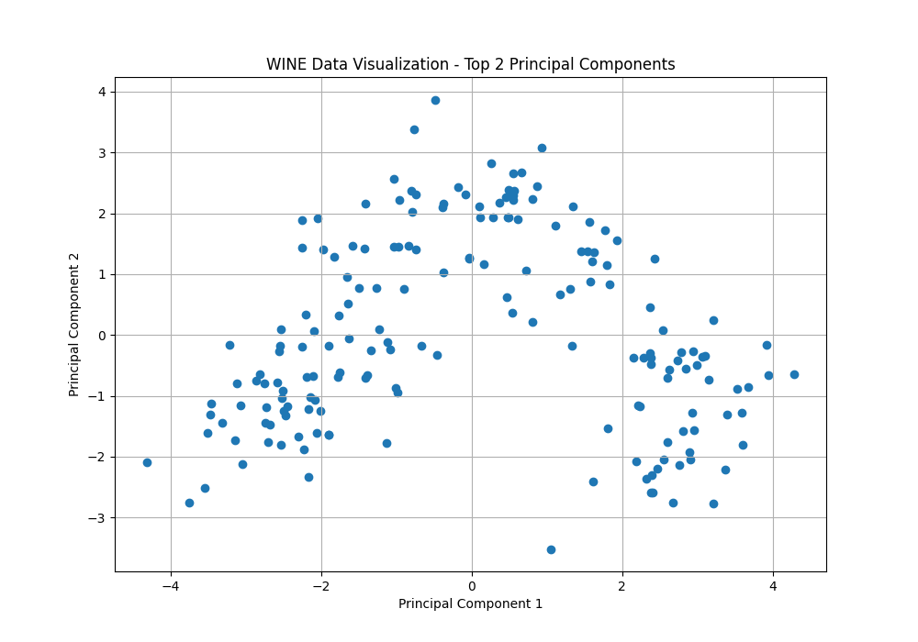
The dataset was projected onto the top 2 main components for 2D visualization. The scatter plot below shows the WINE data distribution in this reduced latent space.

Figure 1: Visualization of WINE data using the top 2 Principal Components.

5.2. Clustering Experiments
K-means clustering (K=3) was performed in three experiments, using the Top 2, Top 5, and Top 8 principal components (PCs), respectively. The following table summarizes the final centroids and cluster sizes for each experiment.
Experiment (Input Data) | Cluster ID | Number of Items | Centroid Coordinates (approx.)
1. Top 2 PCs | 1 | 62 | [0.25245407, 1.79727782]
 | 2 | 49 | [ 2.74392982, -1.2141906 ]
 | 3 | 67 | [-2.24036885, -0.77516247]
2. Top 5 PCs | 1 | 51 | [ 2.72003575, -1.12565126, -0.23909324, -0.06245694, 0.073676 ]
 | 2 | 63 | [ 0.08953541, 1.79399097, 0.23050029, -0.11577413, -0.0348123 ]
 | 3 | 64 | [ 2.72003575, -1.12565126, -0.23909324, -0.06245694, 0.073676 ]
3. Top 8 PCs | 1 | 51 | [ 2.72003575, -1.12565126, -0.23909324, -0.06245694, 0.073676, 0.09992522,  0.06038317, -0.00738799]
 | 2 | 65 | [ 0.03695661, 1.77223945, 0.18613873, -0.08023971, 0.07087807, 0.12980577,  0.00232729, -0.01801532]
 | 3 | 62 | [-2.27619360e+00, -9.32054027e-01, 1.52803156e-03, 1.35498147e-01,  -1.34912110e-01, -2.18283242e-01, -5.21099249e-02, 2.49642497e-02]
(Note: Since K-means initialization is random, the cluster indices 1, 2, and 3 are arbitrary and may swap between runs).

6. Conclusion
Successfully implemented PCA and K-means from scratch. PCA effectively reduced the WINE dataset's dimensionality, enabling a clear 2D visualization. K-means partitioned the data into three clusters across 2D, 5D, and 8D feature subspaces. This highlights the value of standardization and PCA as a preprocessing step for high-dimensional data clustering.

